8.3 Games:
Click on the link in the electronic Menu on One Drive.
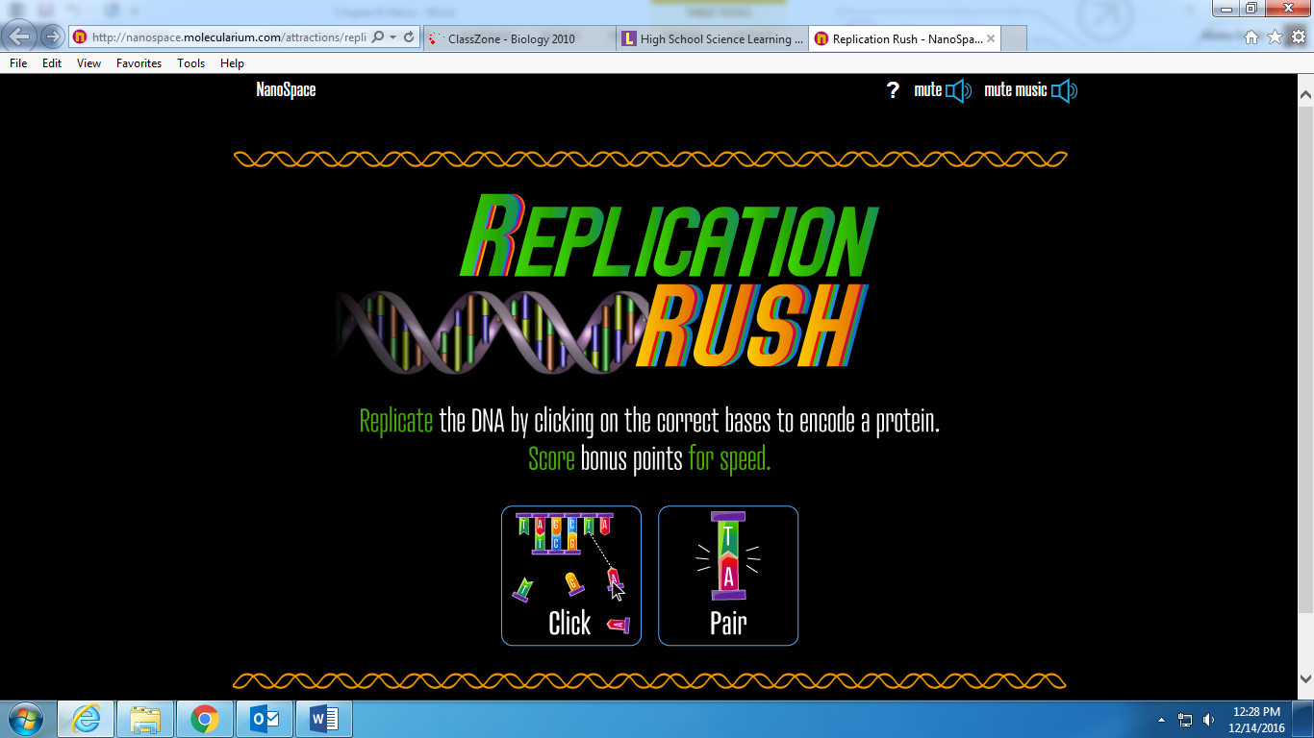
0r
